**Website for Educational Materials**

<http://www.bayridgepediatrics.com/services.html>

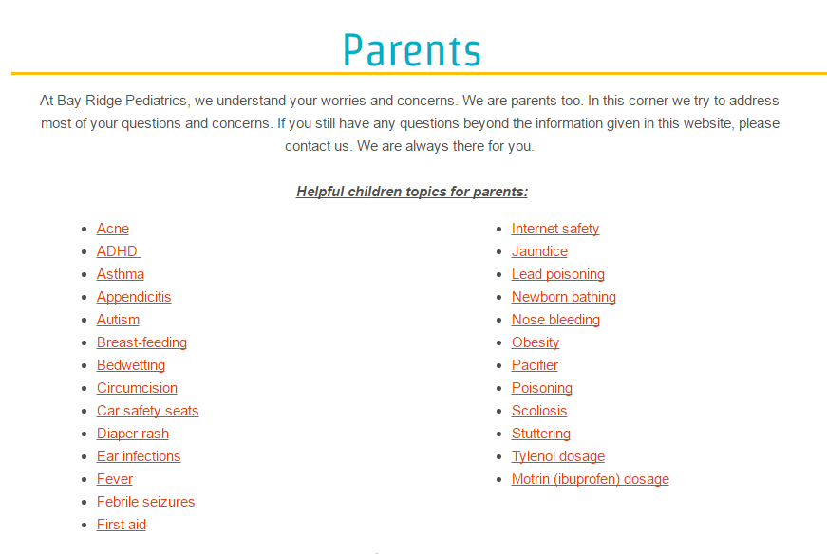

<https://www.healthychildren.org/English/ages-stages/baby/bathing-skin-care/Pages/Bathing-Your-Newborn.aspx>